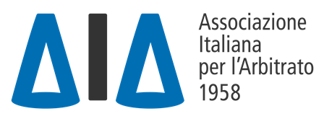
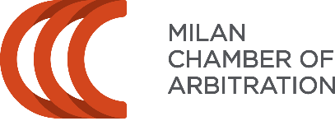

IX AIA-CAM Pre-Moot

IX AIA-CAM PRE-MOOT
1-2 February 2023

CALL FOR ARBITRATORS

Please fill in and return via e-mail at
aiacam.premoot@gmail.com

Rome-Milan, 14 November 2023
Dear All,
The Italian Association for Arbitration (AIA) and the Milan Chamber of Arbitration (CAM) have been jointly organizing the AIA-CAM Pre-Moot for teams participating in the Willem C. Vis International Commercial Arbitration Moot.
We are proud to announce that the IX edition of the AIA-CAM Pre-Moot will take place in Milan at the Milan Chamber of Arbitration (Via Meravigli, 9/B, 20123 Milano) on 1 and 2 February 2023.
We are glad to invite you to join us as an arbitrator by submitting your availability and cross out one or more of the following options:

2 February 2024 | Time | Available?
Round 1 | 10.00-11.30 CET
Round 2 | 12.00-13.30 CET
Round 1 | 14.30-16.00 CET
Round 2 | 16.30-18.00 CET

Please indicate the description, if any, that follows your name by clarifying:
- PARTNER / ASSOCIATE / LAWYER / OF COUNSEL / TRAINEE AT [NAME OF YOUR LAW FIRM] IN [CITY]
- PROFESSOR OF [...] AT [..] UNIVERSITY.
- FURTHER OR DIFFERENT QUALIFICATION [...]

Once we receive your availability, please consider that we rely on your commitment.
The name of the teams that you arbitrate will be provided shortly before the AIA-CAM Pre-moot takes place.

